Phono Solar Technology Co. Ltd., was founded by SUMEC Group Corporation (SUMEC GROUP), a member of the China National Machinery Industry Corporation (SINOMACH).
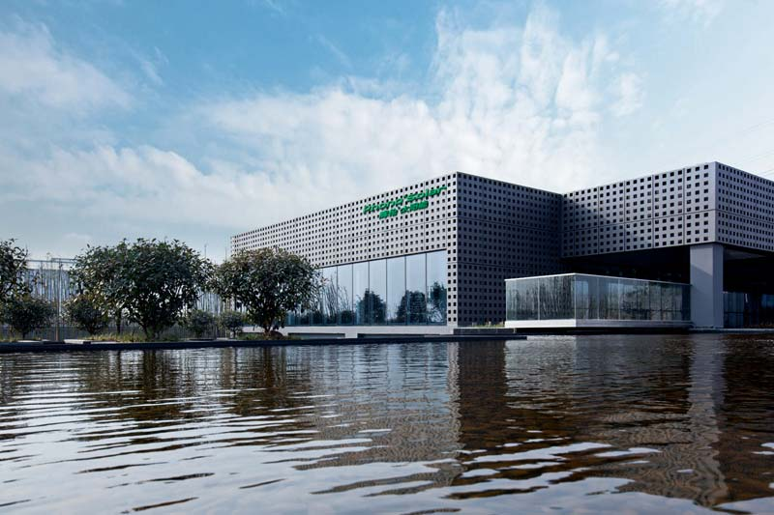
PHONO started our renewable energy business in 2004.
Driven by innovations in technology and an effective brand strategy, Phono Solar continuously extends the industry chain downstream and has realized moderate horizontal expansion to transform into a RENEWABLE ENERGY SOLUTION PROVIDER, who is committed to customer packaged solution for

ENERGY SUPPLY
ENERGY MANAGEMENT
ENERGY SAVING
ENERGY STORAGE
This has been achieved through cutting-edge applications of technology on residential & commercial systems, smart micro-grid systems and also through the successful implementation of PV power plant developments, Br
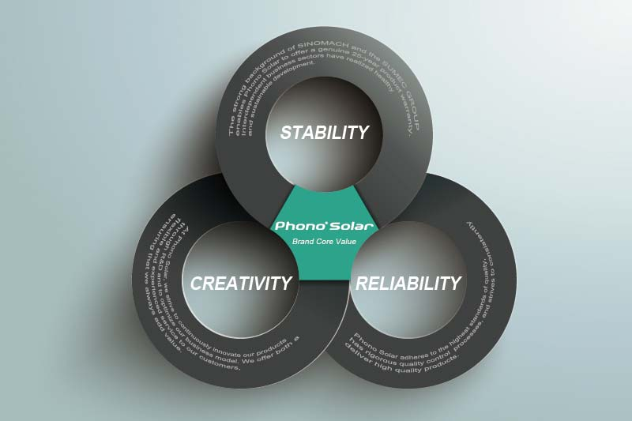
ore Value
Brand Core Value
STABILITY The strong background of SINOMACH and the SUMEC GROUPenables Phono Solar to offer a genuine 25-year product warranty. Interdependent business sectors have realized healthy and sustainable development.
RELIABILITY Phono Solar adheres to the highest standards of quality, has rigorous quality control processes, and strives to consistently deliver high quality products.
CREATIVITY At Phono Solar, we strive to continuously innovate our products through R&D and to optimize our business model. We offer both a flexible and experienced service to our customers, ensuring that we always add value.
investments and operations globally.

MilestonesMilestones
1978 | SUMEC GROUP founded in Nanjing, Jiangsu
1997 | SINOMACH founded in Beijing, China
2004 | One of the FIRST central governmental enterprises to be involved in the PV industry
2008 | Phono Solar 120MW production line established
2009 | Expansion of production line capacity from 120MW to 200MW due to upgrading reconstruction
2010 | Phono Solar realized one of the world's largest PV power plants, 35MW in Veprek, Czech Republic | Phono Solar world leading PV-laboratory in operation
2011 | SINOMACH listed in TOP Fortune Global 500 | Phono Solar 250MW advanced production line completed
2012 | 600,000m² land allocated for further expansion | Plans to establish SINOMACH Renewable Industry Base/Academia Sinica Nanjing Branch| Phono Solar gets official sponsor of Borussia Dortmund
2013 | SINOMACH listed in TOP Fortune Global 500 on #326
2014 | Recognized as Tier 1 by Bloomberg BNEF
2014 | SINOMACH listed in TOP Fortune Global 500
2015 | Total developed PV power plant in China beyond 800MW

Certified with ISO 14001, Phono Solar is dedicated to minimizing the harmful effects on the environment caused by our activities. We comply with applicable regulatory requirements and seek to continuously improve our environmental performance. Through the acquisition of OHSAS 18000, which enhances overall safety awareness, provides an effective control for accidents and avoids damage to the interests of both employees and enterprises, we have strengthened the company's occupational health and safety management, while improving the management level.
Phono Solar is a member of the PV CYCLE association and is committed to establishing a voluntary return and recycling program for end-of-life solar modules. Click here, to download our PV CYCLE certificate.

